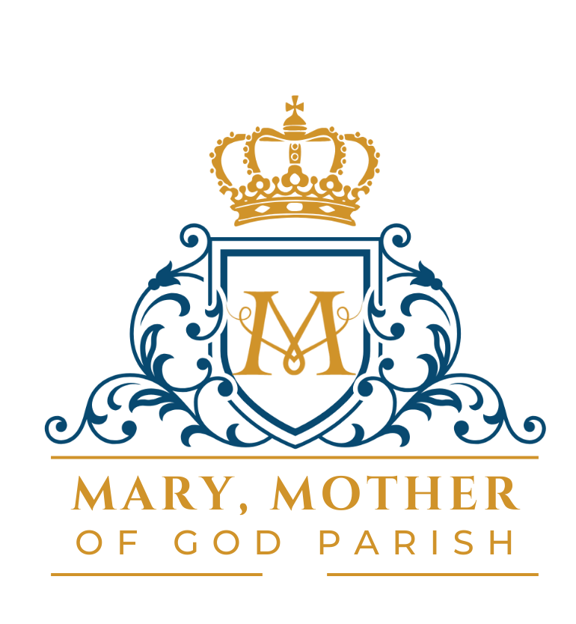
FIRST COMMUNION REGISTRATION FORM

Child’s Name _____________________________________________________

Date of Birth _____________________________________________________

Father’s Name ____________________________________________________

Mother’s First and Maiden Name _____________________________________

Date of Baptism ___________________________________________________

Church of Baptism _________________________________________________

City/State of Church ________________________________________________

NOTE: If the child was baptized at Mary, Mother of God Parish: St. Patrick Church or St. Monica Church, the above information is sufficient. If not, YOU MUST PROVIDE A COPY OF THE BAPTISMAL CERTIFICATE FROM THAT PARISH.

