**“All Souls” Night Trivia**

**to benefit the**

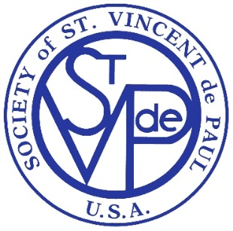**St. Vincent de Paul Society of**

**St. Monica & St. Patrick**

**at St. Monica Church Hall**

**303 Campanile Dr. - East Peoria, IL**

**November 2, 2019**

**Doors open at 5:00 for spaghetti dinner with Trivia at 6:00**

**(Gluten free bread available, but please let us know if you will need it.)**

**$20 per person. BYOB.**

**Sign up as a Team of 8 or let us craft an awesome team for you with other brilliant people.**

**Reservations – Deadline 10/28. See below for options to register.**

**Amazing basket raffle and Silent Auction available.**

**___________________________________________________________________**

Names: ______________________________________________________________

Phone: ___________________ Emails: _____________________________________

Team Captain Name __________________________________

 I have an existing team _____________________ (captain name) or Craft a brilliant team for me

______ number attending @ $20 per person

Registration form with money can be turned in by any of the following ways.

1. Put in church collection basket. Please put TRIVIA NIGHT on envelope.

2. Mailed to: Trivia Night, c/o Angie, 640 W. Cruger Rd, Washington, IL 61571

3. Emailed to: [jdeeb1987@gmail.com](mailto:jdeeb1987@gmail.com)

Please may checks payable to: ***St. Vincent de Paul Society***with Trivia on the memo line.