St. Patrick Church
Washington, Illinois
Marriage & Wedding Policy

Dear Engaged Couple,
Congratulations! Now that you've made the decision to get married, no doubt you have already started planning your wedding. You've probably started looking around for different ideas to make your wedding something really special. And, as you've looked, you probably found more than enough resources for planning a wedding. They're not hard to find; florists, photographers, the city newspapers, and many others are putting out many different guides to wedding planning these days. While all of those are fine in their own way, it seems appropriate that the Church should offer both some guidelines and some support in planning a wedding that is truly an experience of faith and worship.

Rather than approach the wedding first from the point of view of flowers, photos, clothing and other commercial concerns, we would like for you to be able to approach your wedding from the basic understanding that the Church has of marriage, that it is, a sacrament. The following pages are meant to be a guide and support to help you in that approach. Read it well and become familiar with the thoughts and ideas expressed. They will be important to you in your preparations for the meaningful celebration of the Sacrament of Matrimony.

Please visit the Diocese of Peoria website at https://www.cdop.org/marriage
for more information. Be sure to meet with your parish priest prior to enrolling in the following required Genesis Retreat:

Part A - The Theology of Marriage
Saturday’s focus is on God’s plan for you, your spouse, and your marriage. We will begin sharply at 10 AM so please arrive at the retreat center for check in at 9:30 AM. You should plan for programming to end around 7:30 PM. Lunch and Dinner are provided in your registration cost.

Part B - The Skills of Marriage
Sunday’s focus in on sharpening your skill set and equipping you and your spouse to love in a free, total, faithful, and fruitful love. We will begin sharply at 9:00 AM. You should plan for programming to end around 3:00 PM and Mass will be included. A meal is provided with your registration.

Overnight Housing Available
Thank to generous donations, we are able to provide discounted housing for $50/person ($100 for the couple). All rooms are individual.

THE SACRAMENT OF MARRIAGE:

The union of a man and woman in the bond of marriage is a sacred union. A Christian Marriage is more than a civil contract, it is an interpersonal relationship between two persons and the love of God. Marriage in the Christian tradition is a covenant relationship drawing strength from the unconditional covenant of Jesus Christ with His people. The Catholic Church in order to preserve and strengthen the gift of the Sacrament of Marriage requires couples to participate in the Marriage Preparation Program as outlined in the Peoria Diocesan Common Policy. The Common Policy has, among others, the following concerns in mind:

1) A concern for the couple to be married. The Catholic Church wishes to encourage those who have decided to be married in the Church and to assist them in the development of the quality of their relationship. There has been built into the policy not just educational opportunities for marriage preparation, but, more important, formational experience enabling the couple to sort through their relationship before their vows.

2) A concern for the Sacramentality of Marriage. The Catholic Church wishes to help the couple properly understand the Sacramentality of the marriage relationship and to help the couple to celebrate marriage as a sacrament.

3) A concern for the good of society. The family is the most basic societal unit. The current rate of divorce in our country suggests that the institution of marriage has been seriously weakened and family life is suffering. It is the concern of the Christian community that the values of a Christian family be honored and enhanced by highlighting the ideals of a Christian marriage as a basis for a Christian family. In presenting this Policy for Marriage and Weddings, the people of the Diocese of Peoria and St. Patrick Church hope to strengthen the stability of marriage within our society and to show engaged couples that the Church does indeed care for their welfare. Engaged couples are reminded that love and good intentions, though essential, are not all that is necessary for a happy and lasting marriage. Finally this policy is not written to make it difficult to marry in the Catholic Church, but rather to help couples realize the seriousness and sacred nature of the Sacrament of Marriage, thus enabling them to develop a beautiful and permanent relationship.

REGULATIONS & FEES:

SETTING THE WEDDING DATE & TIME:
The wedding date should be set soon after the engagement is announced. Normally at least
one member of the engaged couple is a registered contributing member of St. Patrick Church for six months prior to the wedding. Engaged couple must contact the church 8-10 months prior to the wedding in order to complete marriage preparation prior to the wedding.

THE TIME OF A WEDDING:
Only one wedding will be scheduled on a Saturday no later than 1:30pm (to allow time for
pictures before the 4:30pm Mass). Weddings during the week are permitted provided there is nothing on the Parish schedule that would conflict with use of the church facilities. In the Diocese of Peoria, weddings are not permitted on Sunday.

FEE FOR NON-PARISHIONERS: A fee of $300.00 is requested for the use of the facilities. $150.00 non-refundable deposit is due at the time of scheduling the wedding and the other half is due at the rehearsal. This contribution to the parish is not considered a fee for the organist, cantor or a gift to the priest/deacon. These fees are due on or before the rehearsal.

STIPEND FOR PRIEST: $200.00 made payable to presider
ALTAR SERVERS: $10.00 per altar server

MUSICIAN FEES: Accompanist: $150.00 made payable to the Accompanist
Soloist (each) $100.00 made payable to the Soloist
Instrumentalist $100.00 made payable to each Instrumentalist
Choir: $200.00 made payable to St. Patrick Church

**You must contact the parish Music Director to confirm fees and review music selections.

REHEARSAL:

- The rehearsal is normally held the day before the wedding usually around 5pm.
- Musicians should not attend the rehearsal. Due to time allotted for rehearsal, there will not be time for the musicians to practice during the rehearsal.
- ALL fees are due at the rehearsal with the exception of the non-parishioner deposit which is due at time of scheduling.
- Be sure to bring your marriage license.

DECORATING THE CHURCH:

SET-UP: The church may be decorated one and one half to two hours before the scheduled wedding provided there is nothing else scheduled in the church.

SANCTUARY: Flowers, greenery, and other decorations approved by the Parish Office may be used in the sanctuary. Provisions should be made that wax, water, and greenery do not mar the carpet, tile or woodwork in the sanctuary. The furniture in the sanctuary may not be moved or removed. (The couple is responsible for informing the photographer and the person doing the video that they are not to move any of the furniture.) During certain Liturgical seasons (i.e., Christmas, Lent, Easter, etc.), the decorations in the sanctuary may NOT be removed.

DRESS CODE: Out of respect for the sacredness of the Catholic Church, all brides and bridesmaids are expected to show Christian modesty when choosing a bridal gown or bridesmaid dress for the wedding and rehearsal.

UNITY CANDLE: The unity candle is not mandatory since it is NOT part of the marriage rite.
However, if a unity candle is desired, it needs to be provided by the couple and will be placed on
a small table near the ambo (and should not damage the table). The two altar candles already in place could serve to represent the couple’s individual candles.

AISLE RUNNER: An aisle runner is NOT permitted.

PEW DECORATIONS: Absolutely NO tape, tacks, nails, or wire should be used to attach
anything to the pews. Only plastic pew fasteners provided by the florist, may be used.

ROSE PETALS: Rose petals are permitted if they are cleaned up afterwards.

WAGONS AND PETS: The use of a wagon in the entrance procession for children is not
allowed. Pets are not allowed.

CLEANING THE CHURCH: The decorations, candles and anything else used for the wedding should be completely removed from the church following the wedding and picture taking. You may leave floral arrangements in the church for the Sunday Liturgies; otherwise the parish is not responsible for anything left behind. If there are programs used, these should be removed from all the pews by the ushers or others.

DRESSING ROOMS: The bride and her attendants may use the cry rooms to dress. The rooms are available for no more than 2 ½ hours before the scheduled wedding. Both cry rooms are expected to be clean and orderly before the couple leaves the church. All hangers, plastic bags, and other disposal items should be removed completely from the room.

RECEIVING LINE: The bride and groom may greet their guests after the ceremony in the vestibule of the church (however this is not always practical due to the size of the vestibule) or outside. Because of time limitations a receiving line at the church is not advisable if the couple is planning on pictures after the ceremony. A couple is not permitted to re-enter the church to dismiss guests in the center aisle.

RICE THROWING, BIRD SEED, CONFETTI, BUBBLES AND BALLOONS: According to our Diocesan Insurance policy and the mess it leaves in the church, rice, bird seed, and confetti are not permitted to be thrown in or around the area of the church. Bubbles are permitted provided they are distributed outside the church and outside gathering space.

PHOTOGRAPHY AND VIDEOTAPING: The liturgy during which you celebrate your marriage is a sacred moment of rejoicing in prayer, song and gesture. While we understand your desire to record this moment, picture taking is not the focus of the day and so we ask you to observe the following so that the sacred joy of this day will not be marred by photo and taping equipment and those who operate it. Photographers and those taking videos are not permitted to roam about once the liturgy has begun. There should NOT be any disruption of the flow of the entrance procession or ceremony because of pictures.

Photographers and videographers or any equipment are NOT permitted in the sanctuary. Photographers typically may stand in the side aisles. Only the lighting already available in the
church may be used. No additional lighting may be brought into the church during the ceremony.
Photographs in the church are limited to ONE HOUR ONLY before or after the ceremony. If the wedding is in the afternoon the picture taking will have to be completed by 3:00 p.m. Couples are responsible for informing their photographer about these policies.

MUSIC AT YOUR WEDDING: A wedding is a time of joy and celebration and music occupies an important place in the wedding liturgy. There is a wealth of music available which can enhance the beauty of your wedding, be inspiring to those in attendance, and be long cherished in your own memories.

Music at weddings should invite those gathered to sing the prayer of the Christian community. Solo or instrumental pieces should draw those gathered to prayer and unity, rather than entertainment. A song which may have personal meaning for the bride and groom and which may express personal human love is only appropriate if it also expresses a Christian view of love and worship. Texts should clearly affirm a relationship with God. They should be in keeping with the belief of Catholic Christians, and be drawn primarily from scripture and from the liturgy. The desired end in all the music performed, vocal and instrumental, is an experience of communal prayer. Therefore, secular songs are not appropriate and not allowed.

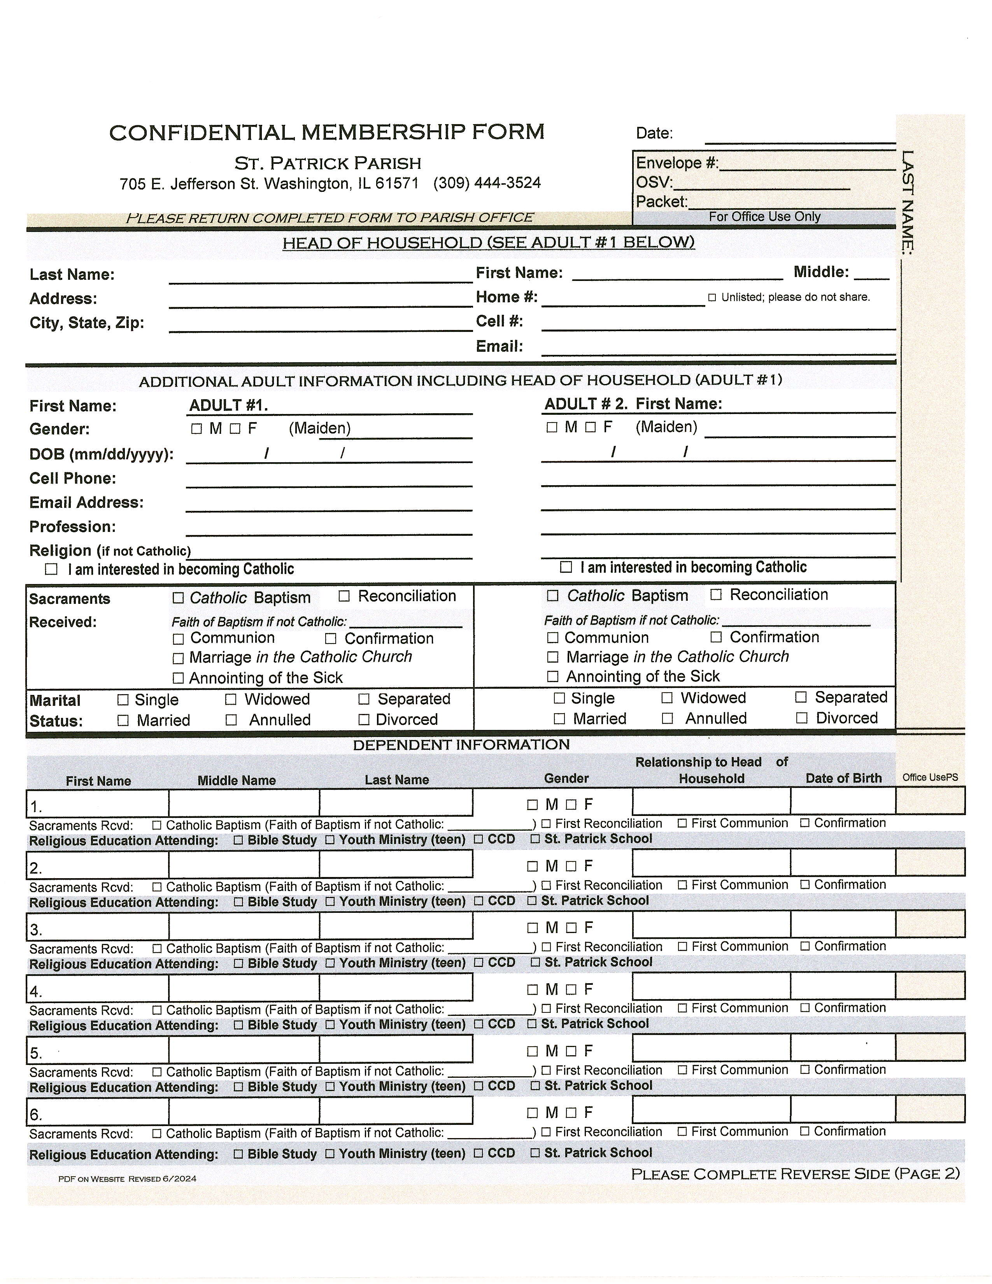
Music adds much to celebrations of the community especially when the community understands that the primary purpose of music is to aid their prayer. The singing of the assembly is to be preferred, even though a vocal soloist may be appropriate at certain times before and during the liturgy. At times a request for a particular song cannot be honored. This does not imply that such music is bad; it is simply not appropriate in the church service. It might well be included in another part of the wedding celebration such as the reception. Since many or most couples have limited awareness of appropriate sacred wedding music, it is required that you contact the parish's Choir Director. She can make known to you some of the perhaps less familiar, but beautiful, possibilities available for your wedding.
No tape or CD music is allowed for accompaniment for a group or soloist.

An experienced cantor from our parish or one who has experienced in Catholic liturgies is required. Because of inexperience, normally relatives or friends who are untrained musicians should not be encouraged to provide music at the wedding service. If you do involve a musician outside of the parish, that person should work in partnership with the parish’s Directory of Liturgy. Many times, outside musicians may not be Catholic, or familiar, with the order and structure of the wedding liturgy. Also, people who may be good musicians do not necessarily have the gift of leading an assembly in community song. Leadership qualities and liturgical skills are essential. To have a musician without such skills given the responsibility of leading the assembly, is to put extreme pressure on them, and it can result in nervousness and discomfort, resulting in a very anxious and stressful situation. A couple's wedding day is certainly a significant event. Therefore, it is our hope that through the music you choose, this special day will be most joyful and prayerful.

REGISTERING AS PARISHIONERS: We have included a form in this packet for you to complete and return to the parish office. This form registers you as Parishioners of St. Patrick Church as a married couple.
Revised: March 2025

